History 280: United States Environmental History

Course Meetings: Tuesday and Thursday 11:00-12:15  CCC 128  Office Hours: Tuesday and Thursday, 1:00-2:00pm | UWSP – History Department  473 CCC  Dr. Neil Prendergast  nprender@uwsp.edu
What can the past teach us about sustainability?

That question is at the root of all we’ll do this semester. As an historian, I teach how the past matters today. As an environmental historian, I believe that the lessons of the past should be environmental lessons.

In this class, we look for lessons to guide sustainability in three types of places: cities, farms, and forests. Each has its own development patterns, social problems, and ecological concerns. Getting to know them will give you a running start in addressing many of the environmental problems your generation will face. Your work in this course can prove useful for a number of careers, from forestry to urban planning to real estate to rural development, among much else. (It’s also just plain interesting.)

In each unit, we will keep in mind the components of sustainability: justice, economics, and ecology. As it turns out, Americans have long thought about these themes, well before the notion of sustainability came on the scene. That’s good for us, because it means we can learn from people who have already thought about the things we care about. The past is full of people who can help us decide how to build cities, farm soil, and manage forests.

Enduring Understandings:

Sustainability requires understanding the lessons of the past.

Learning Outcomes: After taking this course, students will be able to:

- Describe and explain major changes in the history of the United States environment
- Evaluate competing claims about the nation’s environmental past
- Question the landscape around them with thought and care

Course Structure and Assignments: To make our big sustainability question manageable, the course asks it within six different case studies. | 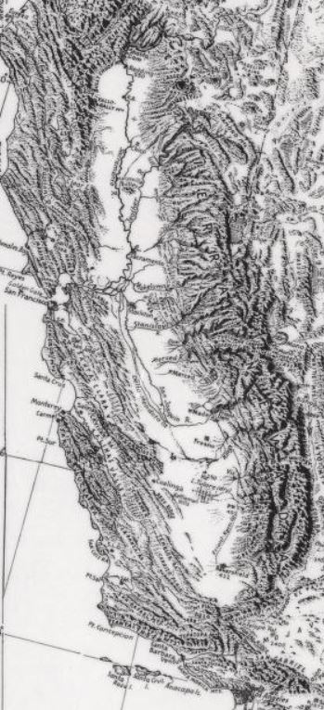
What caused the Dust Bowl?

How did California become the nation’s leading farm state?

What destroyed the native longleaf pine forest in the American South?

How did Great Lakes forests recover from nineteenth-century logging?

Why did New Orleans fare so poorly in Hurricane Katrina?

Why is Portland such a green city?

These questions take us across the United States and not just to situations that proved environmentally disastrous. We’ll learn from the good and the bad—and realize the two often come hand in hand.

Regular Work: At the end of some class periods, I will assign a short writing due in the next class meeting.

Exam: At the end of unit is an exam. It will be a combination of multiple choice, short answer, and the like. The best way to prepare for the quiz will be to read before class, participate in discussion, complete any handouts, and contact or visit me with any questions. Details when we approach the first quiz.

Paper “Lessons from the Past”: In this assignment, students will respond with an historical perspective to present day ideas. An assignment description will be available in the first few weeks of the semester. Graded papers can be revised for partial credit, provided they are submitted before Thanksgiving. Details on the assignment sheet.

Paper “Place”: This paper asks you to draw on your semester’s knowledge of environmental history. It serves as our final exam. In brief, your paper will advise planners on how to use the history of a place to plan for its future. An assignment sheet will be available midway through the semester.

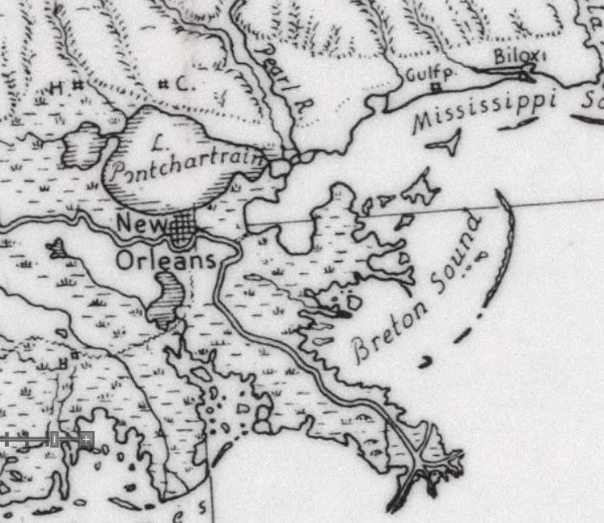 | Office Hours: You are welcome to visit me in my office. I set aside office hours so that I have the chance to talk with students one-on-one. From 1:00-2:00pm Tuesday and Thursday, I do not have any other commitments. My only commitment is to speak with my students.

Readings: Our readings will be on Canvas as downloadable PDF’s. Each is a groundbreaking article or book chapter by a leading scholar. Print the articles and bring them to class.

Grading: 2 points each for 10 items of Regular Work + 40 points for each of Three Exams + 30 points for Lessons of History Paper + 30 points for Place Paper = 200 semester points.

Letter grades for the semester follow the typical pattern:

A 93-100 | B+ 87-89.99 | C+ 77-79.99 | D+ 67-69.99 | F 59.99 and below
A- 90-92.99 | B 83-86.99 | C 73-76.99 | D 60-66.99
 | B- 80-82.99 | C- 70-72.99
Advice from Previous Students: Why listen just to me? Here is what your predecessors want to tell you:

“Read the material and attend class.”

“Attend class, pay attention and from there it’s not hard to do well in the class.”

“Stay on top of the reading. It’s not too hard and the lectures cover the material, but the text gives a lot of depth and examples.”

“Involve yourself in the reading, thinking about how you could apply it to what you care about.”

“Be prepared to read! Pick up on little things.”

“Look beyond just the facts, because it is a very beneficial class.”

“Come to class and speak up. Participate. I found the class much more interesting when more people took part.”

Course Policies: During the class, cell phones and other electronic devices are prohibited. If you are a parent or are otherwise obligated to be available to your family via cell phone, then please discuss that situation with me, so I know that you have a good reason for keeping your phone turned on.

The prohibition of electronics also extends to laptop computers (unless approved by the Learning Technology Center). While laptops are great aides in studying, the focus in class is on class, not the computer screen. If you do prefer to have your notes in a computer file, you will find that typing them from your handwritten notes will aid you greatly in digesting the material.

For information on plagiarism, consult http://www.uwsp.edu/centers/rights. See Chapter 14, Student Academic Standards and Disciplinary Procedures, pages 5 -10, for the disciplinary possibilities if you are caught cheating. As an instructor deeply concerned with fairness in the classroom, I pursue each and every case of plagiarism and cheating. Please note that turnitin.com is used for the essay assignments.

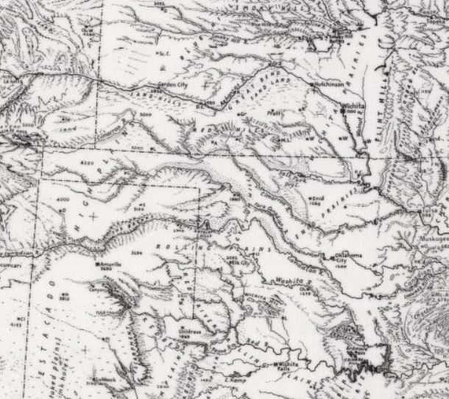 | Life Happens: I understand you have a life outside this class. I understand that life might make it difficult to complete some assignments, attend class, or simply to do well. I do my best to be flexible because I know those circumstances are out of your control and my control. I’m on your team.  I also know that some real learning has to take place in this class. You will have more opportunity in life if you understand history, read critically, and write well. This class has to be one of your priorities. I do my best to be flexible, but I have to adhere to some standards. If something comes up, let’s talk.
Equity of Educational Access: If you have a learning or physical challenge which requires classroom accommodation, please contact the UWSP Disability Services office with your documentation as early as possible in the semester. They will then notify me, in a confidential memo, of the accommodations that will facilitate your success in the course. Disability Services Office, 103 Student Services Center, Voice: (715) 346-3365, TTY: (715) 346-3362, http://www.uwsp.edu/special/disability/studentinfo.htm.

NOTE: This syllabus is a general plan. Changes may be announced in class, via email, or on Canvas. | 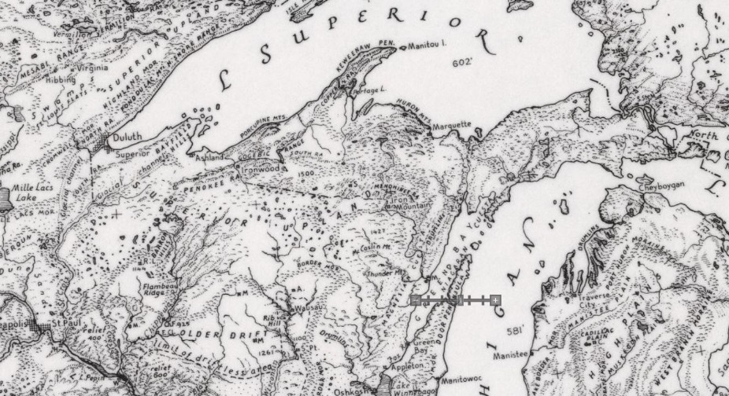
Schedule
Why the History of the Environment Matters
Week 1 | Tuesday  Introduction | Thursday  Lecture: Deep History of North America
FARM: What caused the Dust Bowl?
Week 2 | Tuesday  Lecture: Farm in America | Thursday  Worster, “Grassland Follies”
Week 3 | Tuesday  Cunfer, “Drought and Dust Bowl” | Thursday  Opie, “100 Years of Climate Risk”
FARM: How did California become the nation’s leading farm state?
Week 4 | Tuesday  Walker, “Landscape of Commodities” | Thursday  Igler, “Industrial Cowboys”
Week 5 | Tuesday  Stoll, “White Men and Cheap Labor” | Thursday  Exam
FOREST: What destroyed the native longleaf pine forest in the American South?
Week 6 | Tuesday  Lecture: American Forest History | Thursday  Early, “Exploitation”
Week 7 | Tuesday  Early, “Exploitation” | Thursday  Way, “Burned to be Wild”
FOREST: How did Great Lakes forests recover from nineteenth-century logging?
Week 8 | Tuesday  Johnson, “Conservation, Subsistence” | Thursday  Shapiro, “Tourists Do Not Deplete Soil”
Week 9 | Tuesday  “Menominee Experience” | Thursday  Exam
CITY: Why did New Orleans fare so poorly during Hurricane Katrina?
Week 10 | Tuesday  Lecture: The City and Nature | Thursday  Campanella, “Delta Urbanism”
Week 11 | Tuesday  Campanella, “Ethnic Geography” | Thursday  Landphair, “Lower Ninth Ward”
CITY: Why is Portland such a green city?
Week 12 | Tuesday  Abbott, “Planning a Sustainable City” | Thursday  Stroud, “Environmental Racism”
Week 13 | Tuesday  Exam | Thanksgiving Break
Week 14 | Tuesday  Place Paper Assignment Workshop | Thursday  Place Paper Assignment Workshop
Week 15 | Tuesday  Place Paper Image Show-and-Tell | Thursday  Place Paper Image Show-and-Tell
Final Exam Week | Place Paper due in Canvas by end of Final Exam time. See AccessPoint for exact time.
Note: The Lessons from the Past Paper can be turned in anytime during the semester (before the end of the final exam time). However, to earn the opportunity to revise the paper, students must turn the paper in before Thanksgiving break.

